**Optimizing Sleep Efficiency : Harnessing Machine Learning for Enhanced Restorative Rest**

## Project Description:

The project "Optimizing Sleep Efficacy: Harnessing Machine Learning for Enhanced Restorative Rest" aims to leverage machine learning algorithms to improve the quality and efficiency of sleep for individuals. By analyzing various factors such as sleep patterns, environmental conditions, and lifestyle habits, the system will provide personalized recommendations and interventions to optimize sleep quality and duration. The goal is to enhance restorative rest, promote overall well-being, and mitigate sleep-related issues such as insomnia, sleep apnea and disrupted sleep cycles.

## Project Scenario:

**Scenario 1**: Personalized Sleep Schedule Adjustment

The system collects data on an individual's sleep patterns, daily routines, and lifestyle factors. Using machine learning algorithms, it identifies optimal sleep schedules tailored to the person's circadian rhythm and lifestyle preferences. For example, it may recommend adjusting bedtime or wake-up times to align with natural sleep cycles, resulting in more restorative sleep .

**Scenario 2**: Environmental Optimization for Better Sleep

By integrating data from smart home devices such as temperature sensors, light controls, and noise monitors, the system creates an ideal sleep environment. Machine learning algorithms analyze this data to suggest adjustments like adjusting room temperature, dimming lights, or playing soothing sounds to promote better sleep quality.

**Scenario 3**: Sleep Quality Monitoring and Intervention

The system continuously monitors sleep quality metrics such as REM sleep duration, deep sleep stages, and interruptions. If it detects patterns indicative of poor sleep quality, it provides personalized interventions such as relaxation techniques, sleep hygiene tips, or suggesting adjustments to bedtime routines to improve overall sleep efficacy.



## Project Flow:

* The user interacts with the UI to enter the input.
* Entered input is analysed by the model which is integrated.
* Once the model analyses the input the prediction is showcased on the UI

To accomplish this, we have to complete all the activities listed below,

● DataCollection & Preparation

○ Collect the dataset

○ Data Preparation

* Exploratory Data Analysis
  1. Descriptive statistical

○ Visual Analysis

* Model Building
  1. Training the model in multiple algorithms

○ Testing the model

* Performance Testing & Hyperparameter Tuning
  1. A testing model with multiple evaluation metrics

○ Comparing model accuracy before & after applying hyperparameter tuning

* Model Deployment
  1. Save the best model

○ Integrate with Web Framework

## Prior Knowledge:

You must have prior knowledge of the following topics to complete this project.

* ML Concepts
* Supervised learning: https://www.javatpoint.com/supervised-machine-learning
* Unsupervised learning: <https://www.javatpoint.com/unsupervised-machine-learning>
* Decision tree: <https://www.javatpoint.com/machine-learning-decision-tree-classification-algorithm>
* Random forest: <https://www.javatpoint.com/machine-learning-random-forest-algorithm>
* Hyper parameter Tuning : <https://www.geeksforgeeks.org/hyperparameter-tuning/>
* Flask Basics: <https://www.youtube.com/watch?v=lj4I_CvBnt0>

## Project Structure:

Create the Project folder which contains files as shown below

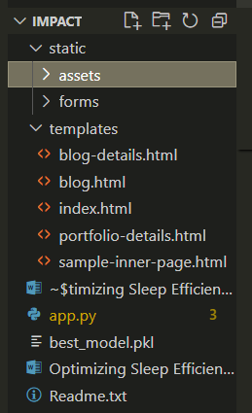

* We are building a Flask application that needs HTML pages stored in the templates folder and a Python script app.py for scripting.
* best_model.pkl is our saved model. Further, we will use this model for flask integration.
* App.ipynb contains a model training file.

# **Milestone 1: Data Collection & Preparation**

ML depends heavily on data. It is the most crucial aspect that makes algorithm training possible. So, this section allows you to download the required dataset.

## Activity 1: Collect the dataset

There are many popular open sources for collecting the data. Eg: kaggle.com, UCI repository, etc.

In this project, we have used .csv data. This data is downloaded from kaggle.com. Please refer to the link given below to download the dataset.

Link: https: <https://www.kaggle.com/datasets/equilibriumm/sleep-efficiency>.

As the dataset is downloaded. Let us read and understand the data properly with the help of some visualization techniques and some analyzing techniques.

**Note:** There are several techniques for understanding the data. But here we have used some of it. In an additional way, you can use multiple techniques.

## Activity 2: Importing the libraries

Import the necessary libraries as shown in the image.

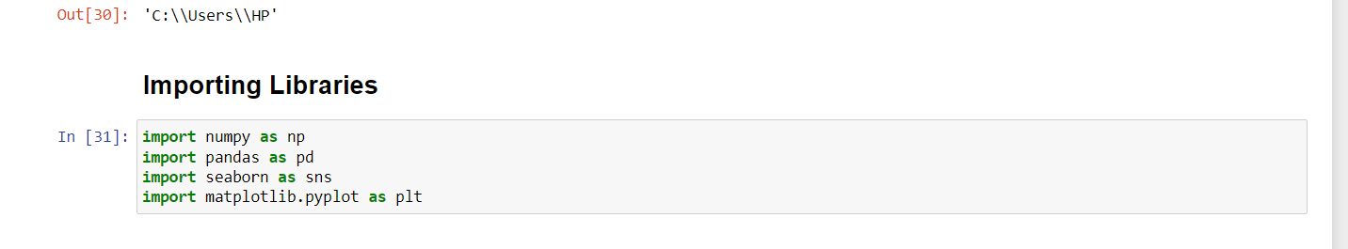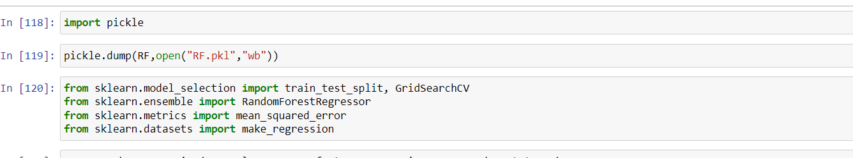

## Activity 3: Read the Dataset

Our dataset format might be in .csv, excel files, .txt, .json, etc. We can read the dataset with the help of pandas.

In pandas, we have a function called read_csv() to read the dataset. As a parameter, we have to give the directory of the CSV file.

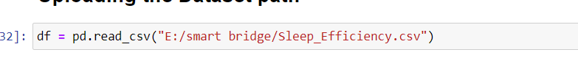

## Activity 4: Data Preparation

As we have understood how the data is, let's pre-process the collected data. The download data set is not suitable for training the machine learning model as it might have so much randomness so we need to clean the dataset properly to fetch good results. This activity includes the following steps.

* Handling missing values
* Handling categorical data
* Handling Outliers

Note: These are the general steps of pre-processing the data before using it for machine learning. Depending on the condition of your dataset, you may or may not have to go through all these steps.

## Activity 5: Handling missing values

Let’s find the shape of our dataset first. To find the shape of our data, the data. shape method is used. To find the data type, the data.info() function is used.

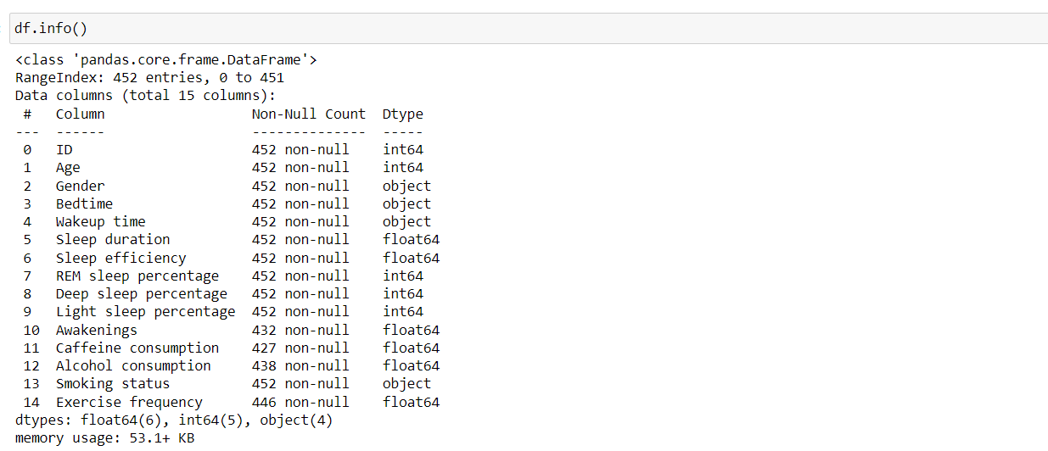

For checking the null values, data.isnull() function is used. To sum those null values we use .sum() function. From the below image, we found that there are no null values present in our dataset. So we can skip handling the missing values step.

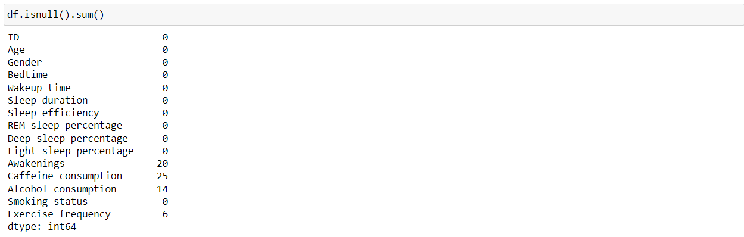

As we can see our dataset has missing values.

As we have fewer missing values so, we now drop the missing values by using the below code.

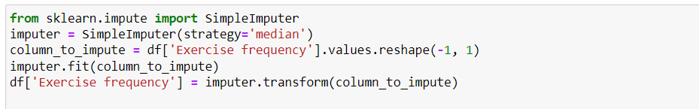

## Activity 6: Handling Imbalance Data

With the help of a boxplot, outliers are visualized. Here we are going to find the upper bound and lower bound of every feature with some mathematical formula.

From the below diagram, we can visualize that every feature has outliers. Boxplot from Seaborn Library is used here.

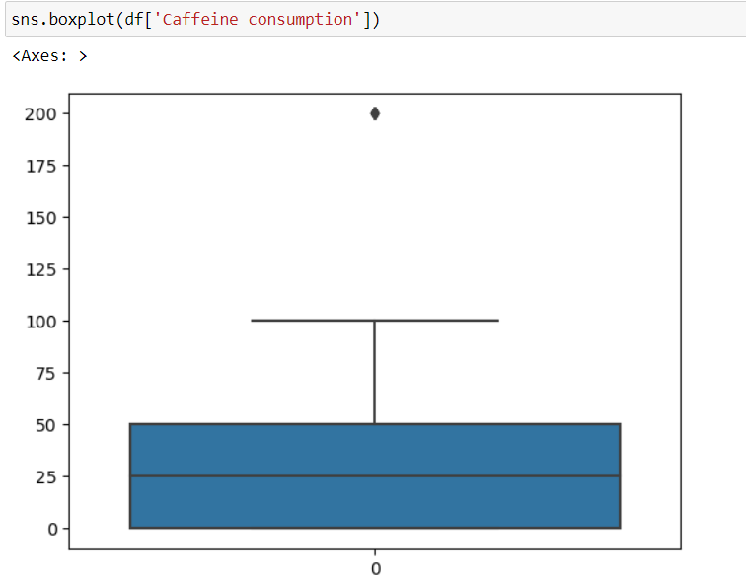

To find the upper bound we have to multiply IQR (Interquartile range) by 1.5 and add it to 3rd quantile. To find a lower bound instead of adding, subtract it with 1st quantile. Take the image attached below as your reference.

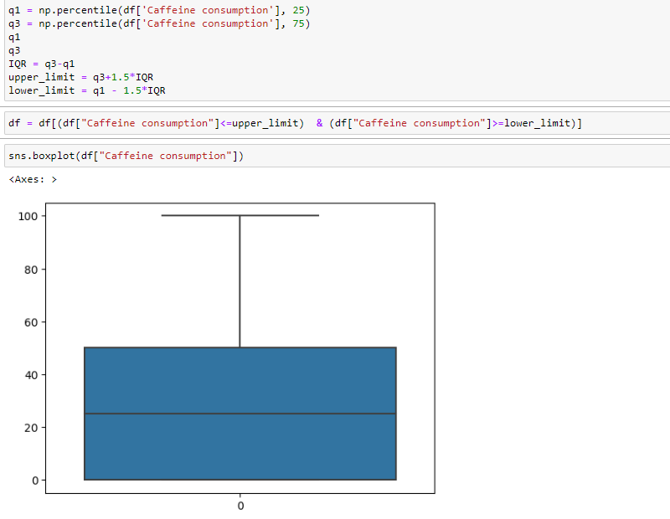

# **Milestone 2: Exploratory Data Analysis**

## Activity 1: Descriptive statistics

Descriptive analysis is to study the basic features of data with the statistical process. Here pandas have a worthy function called describe. With this described function we can understand the unique, top, and frequent values of categorical features. And we can find mean, std, min, max, and percentile values of continuous features.

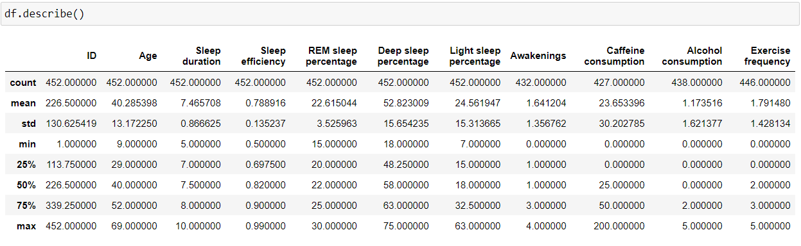

## Activity 2: Visual analysis

Visual analysis is using visual representations, such as charts, plots, and graphs, to explore and understand data. It is a way to quickly identify patterns, trends, and outliers in the data, which can help to gain insights and make informed decisions.

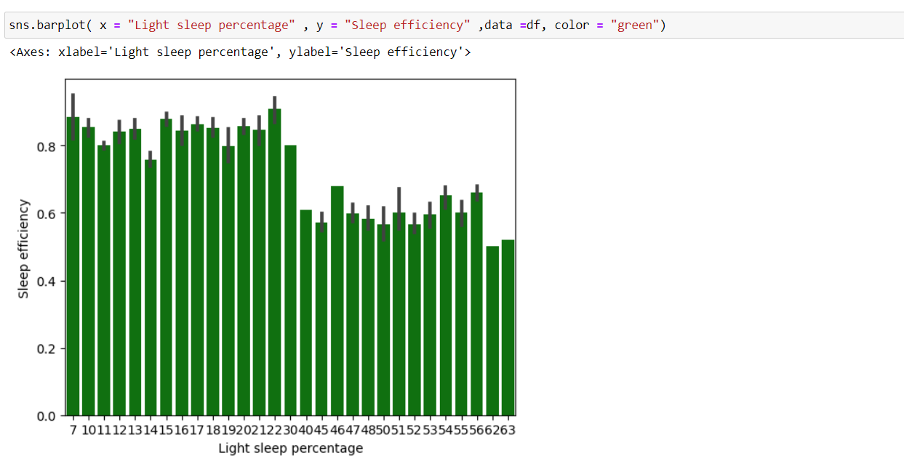

The above code is the count plot where it describes the Quality count and gives the title Distribution of quality.

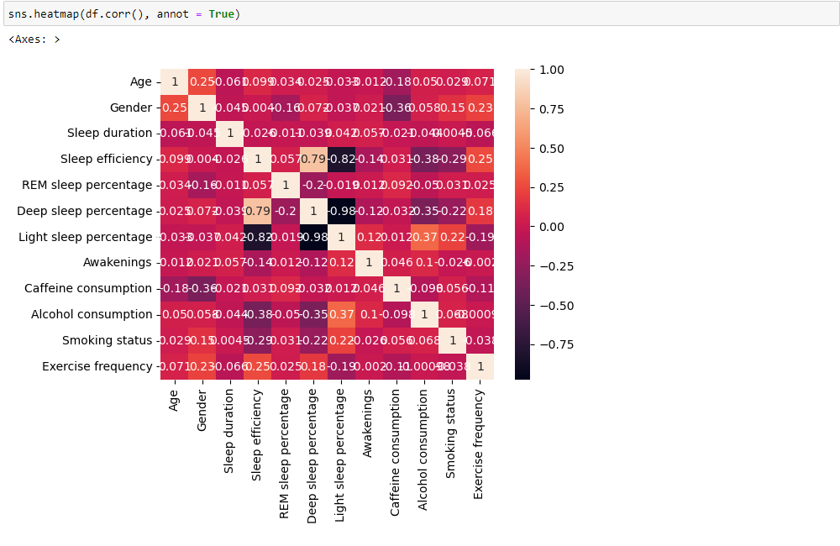

## Activity 3: Splitting data into train and test

Now let’s split the Dataset into train and test sets. First, split the dataset into x and y and then split the data set, here x and y variables are created. On the x variable, data is passed by dropping the target variable. And on y target variable is passed. For splitting training and testing data we are using the train_test_split() function from sklearn. As parameters, we are passing x, y, test_size, random_state.

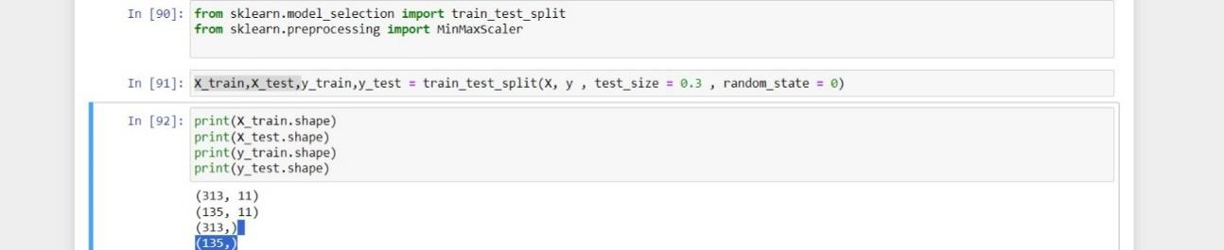

The code imports the MinMaxScaler module from sci-kit-learn for feature scaling. It then scales the features in the input data 'x' using standardization and splits the dataset into training and testing sets with a test size of 30% and a random state of 0.

# **Milestone 3: Model Building**

## Activity 1: Training the model in multiple algorithms

Now our data is cleaned and it’s time to build the model. We can train our data on different algorithms. For this project, we are applying four regression algorithms. The best model is saved based on its performance.

**Model 1 :**

**Linear Regression**

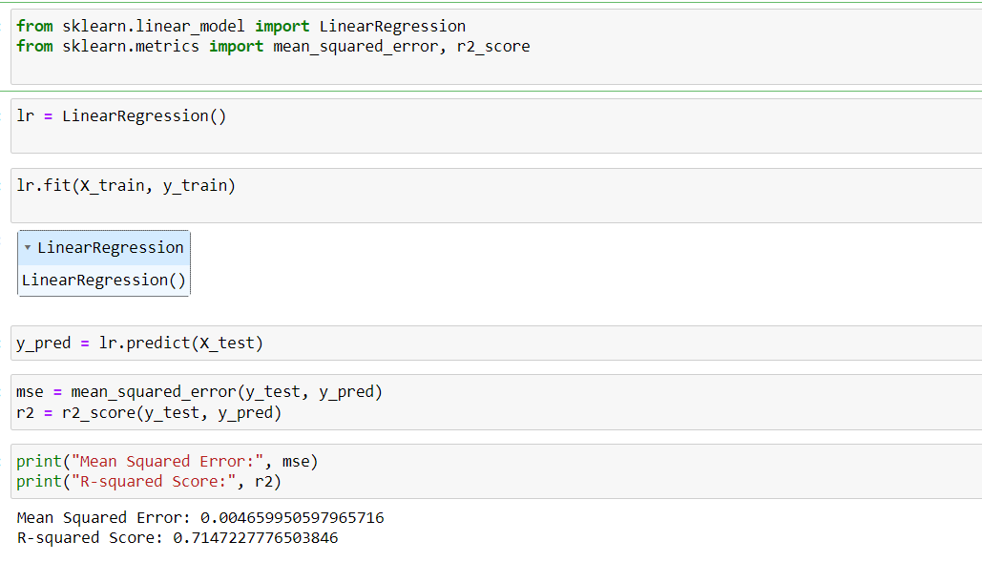

Linear regression is a statistical method used to model the relationship between a dependent variable and one or more independent variables by fitting a linear equation to observed data. It aims to find the best-fitting line through the data points, minimizing the sum of the squared differences between the observed and predicted values. This technique is commonly employed for prediction and forecasting tasks in various fields such as economics, finance, and machine learning.

**Model 2:**

**Decision Tree**

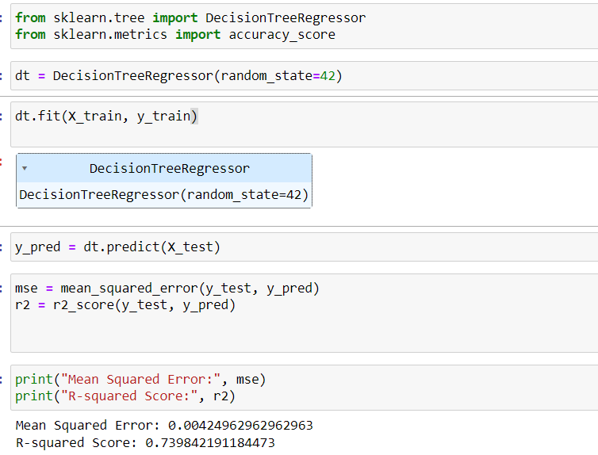

Decision trees are a machine learning algorithm used for both classification and regression tasks. They work by recursively partitioning the data into subsets based on the values of input features. At each step, the algorithm selects the feature that best splits the data, aiming to minimize impurity or maximize information gain. Decision trees are interpretable, versatile, and can handle both numerical and categorical data, making them popular in various domains such as finance, healthcare, and marketing.

**Model 3:**

**Random Forest**

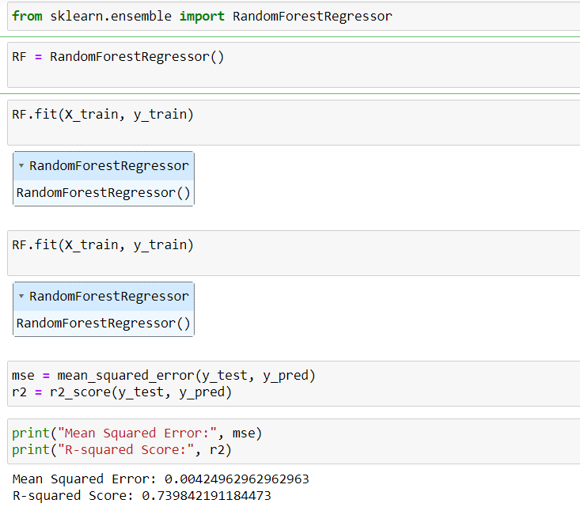

Random Forest is an ensemble learning method that constructs multiple decision trees during training and combines their predictions to improve accuracy and reduce overfitting. Each tree is trained on a random subset of the training data and a random subset of features. The final prediction is determined by averaging or taking a majority vote of the predictions made by individual trees. Random Forest is widely used for classification and regression tasks and is known for its robustness and high performance on various types of datasets.

**Model 4:**

**Hyper Paramter tuning:**

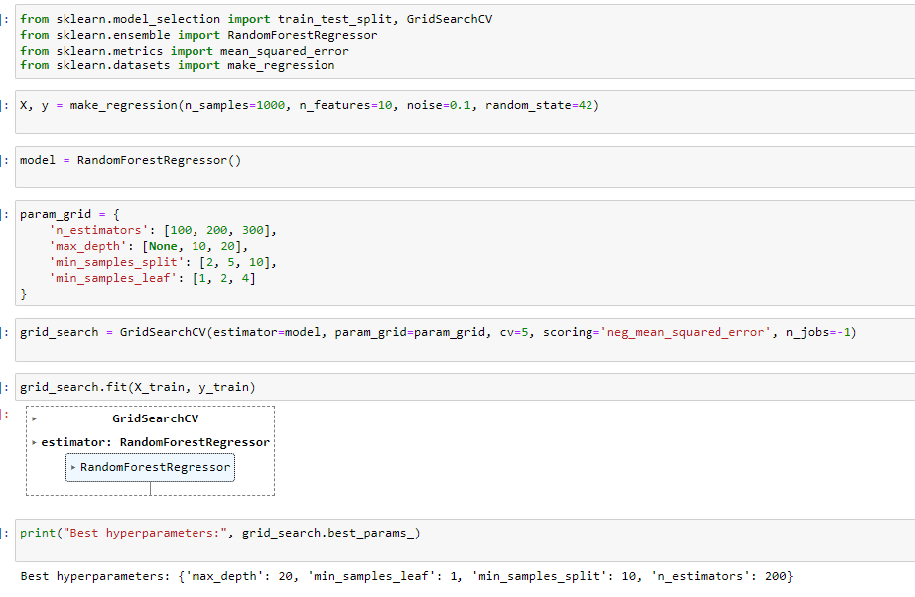

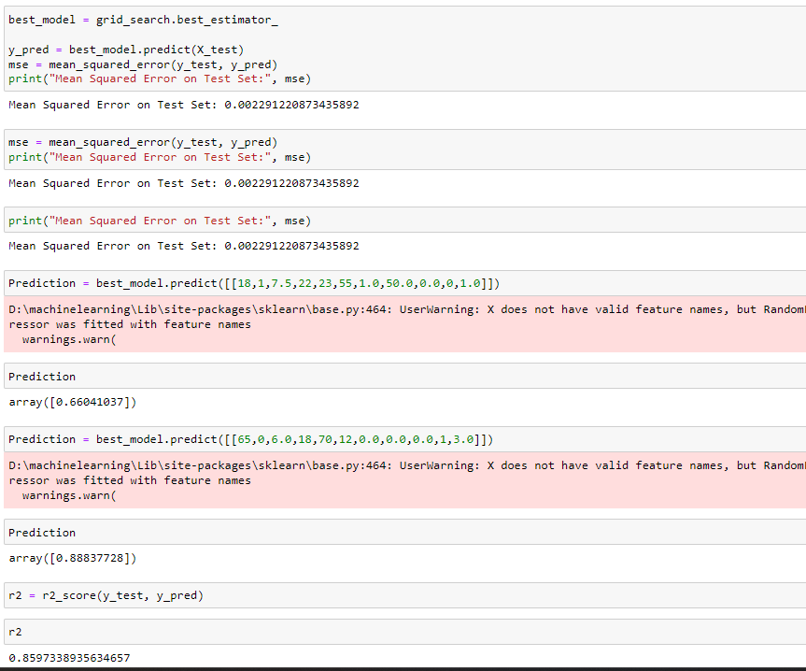

Hyperparameter tuning involves optimizing the settings of a machine learning model that are not learned during training, such as learning rates or regularization parameters. It aims to improve the model's performance by selecting the best combination of hyperparameters through techniques like grid search, random search, or Bayesian optimization. Hyperparameter tuning is crucial for maximizing model accuracy and generalization on unseen data, but it can be computationally intensive and requires careful validation to avoid overfitting.

**Prediction :**

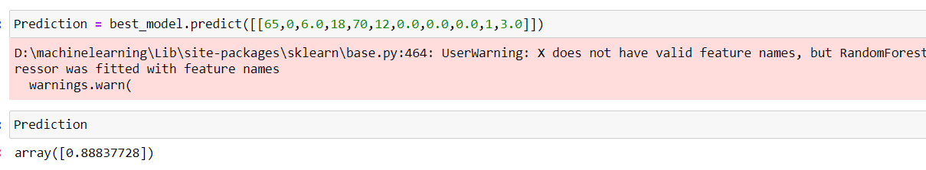

# **Milestone 5: Model Deployment**

## Activity 1: Save the best model

Saving the best model after comparing its performance using different evaluation metrics means selecting the model with the highest performance and saving its weights and configuration. This can be useful in avoiding the need to retrain the model every time it is needed and also to be able to use it in the future.



This code exports the trained machine learning model 'model1' using pickle serialization and saves it as a file named "best_model. pkl". This allows for the model to be easily stored, shared, and loaded for future use without needing to retrain it.

## Activity 2: Integrate with Web Framework

In this section, we will be building a web application that is integrated into the model we built. A UI is provided for the uses where he has to enter the values for predictions. The enter values are given to the saved model and prediction is showcased on the UI.

This section has the following tasks

* Building HTML Pages
* Building server-side script
* Run the web application

**Activity 3: Building Html Pages:**

For this project create two HTML files namely

* index.html
* portfolio-details.html
* blog.html

and save them in the templates folder.

**Activity 4: Build Python code:**

Import the libraries

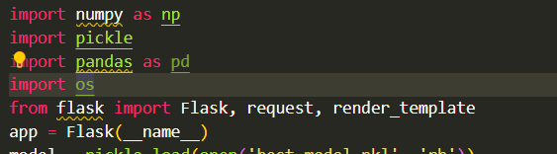

Load the saved model. Importing the Flask module in the project is mandatory. An object of the Flask class is our WSGI application. The Flask constructor takes the name of the current module (__name__) as argument.

Here we will be using a declared constructor to route to the HTML page that we have created earlier.

In the below example, the ‘/’ URL is bound with the home.html function. Hence, when the home page of the web server is opened in the browser, the HTML page will be rendered.

Whenever you enter the values from the html page the values can be retrieved using POST Method.

* Retrieves the value from UI:

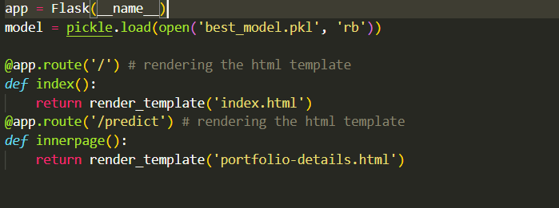

* Here we are routing our app to predict the () function. This function retrieves all the values from the HTML page using a Post request. That is stored in an array. This array is passed to the model. predict() function. This function returns the prediction. This prediction value will be rendered to the text that we have mentioned in the submit.html page earlier.

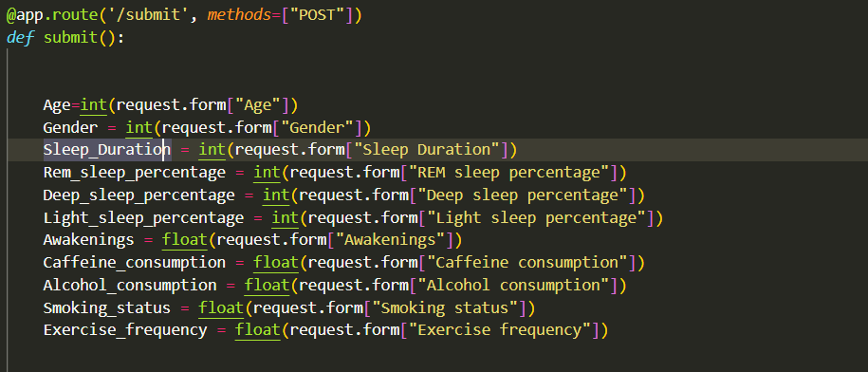

**Main Function:**

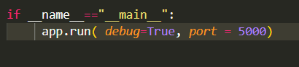

## Activity 5: Run the web application

* Open the anaconda prompt from the start menu
* Navigate to the folder where your Python script is.
* Now type the “python app.py” command
* Navigate to the localhost where you can view your web page.
* Click on the predict button from the top left corner, enter the inputs, click on the submit button, and see the result/prediction on the web.

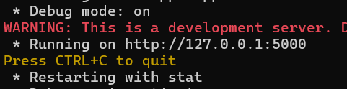

Now, Go to the web browser and write the localhost URL (http://127.0.0.1:5000) to get the below result

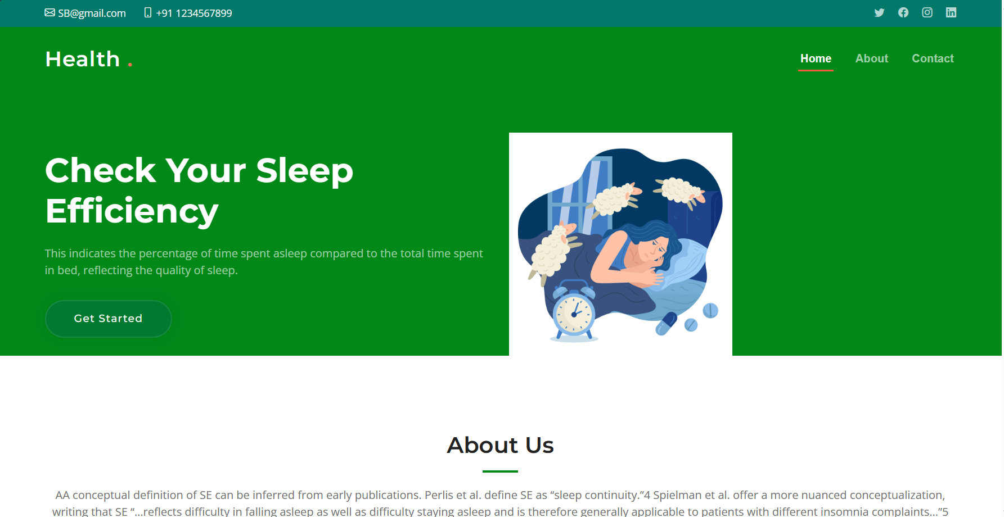

The above UI page is the index page. In the index page, it contains home, about, and contact.

On the page we have Get Started the button click on it. So, that it will be redirected to the inner page.

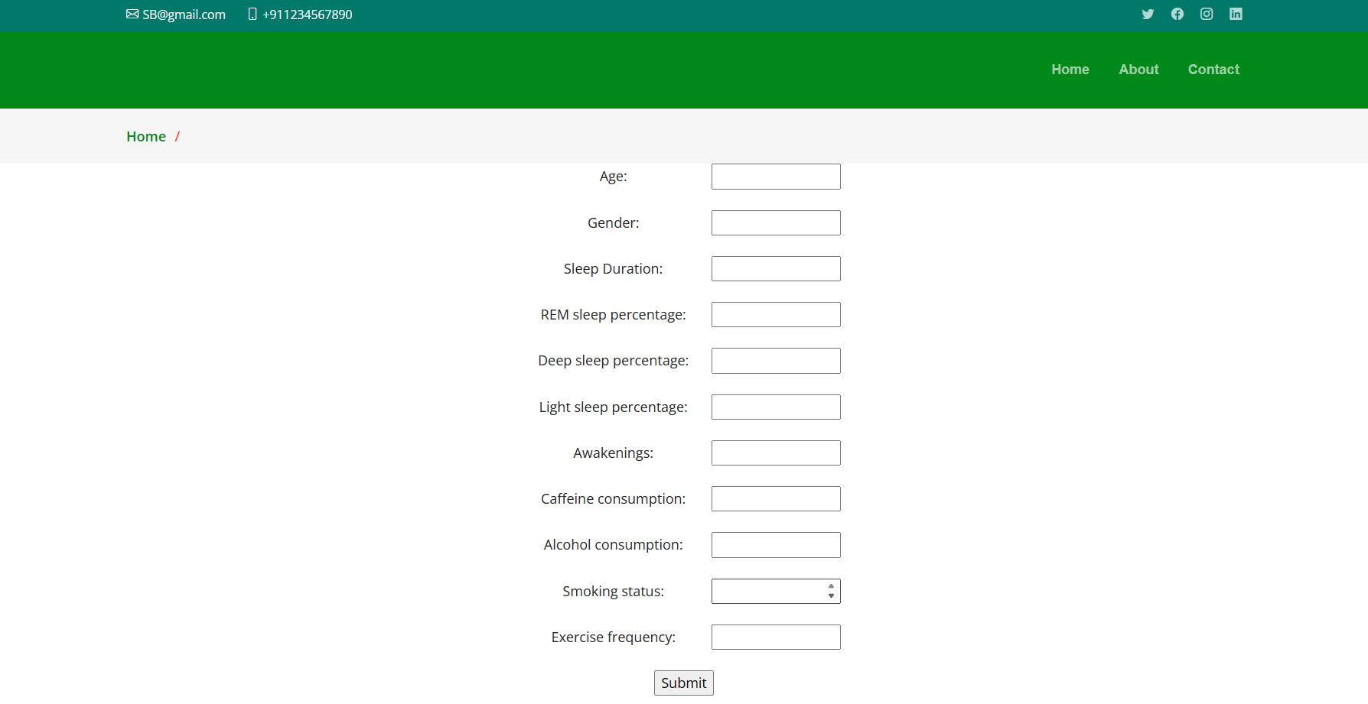

In this page gives the respected values for the respected fields .

**Output :**

In this final page the output that is sleep efficiency will be shown.

